***A Mini Project Report on***

**ML Based**

**Ocean Management System**

**T.E. - I.T Engineering**

**Submitted By**

|  |  |
| --- | --- |
| **Madhu Gage** | **20104037** |
| **Rohan Ahire** | **20104133** |
| **Darpan Mhatre** | **20104019** |

**Under The Guidance Of**

##### Prof. Ganesh Gourshete

****

**DEPARTMENT OF INFORMATION TECHNOLOGY**

A.P.SHAH INSTITUTE OF TECHNOLOGY

G.B. Road, Kasarvadavali, Thane (W), Mumbai-400615

UNIVERSITY OF MUMBAI

**Academic year: 2022-23**

## CERTIFICATE

This to certify that the Mini Project report on PhotoStock has been submitted by **Madhu Gage (20104037), Darpan Mhatre (20104019)** and **Rohan Ahire (20104133)** who are a Bonafide students of A. P. Shah Institute of Technology, Thane, Mumbai, as a partial fulfillment of the requirement for the degree in Information Technology, during the academic year 2022-23in the satisfactory manner as per the curriculum laid down by University of Mumbai.

Mr. Ganesh Gourshete

Guide

Dr. Kiran Deshpande Dr. Uttam. D. Kolekar

HoD, Information Technology Principal

External Examiner(s)

1.

2.

Place: A. P. Shah Institute of Technology, Thane

Date:

**ACKNOWLEDGEMENT**

This project would not have come to fruition without the invaluable help of our guide **Mr. Ganesh Gourshete**. Expressing gratitude towards our HoD, **Prof. Kiran Deshpande**, and the Department of Information Technology for providing us with the opportunity as well as the support required to pursue this project. We would also like to thank our teacher **Ms. Charul Singh** who gave us her valuable suggestions and ideas when we were in need of them. We would also like to thank our peers for their helpful suggestions.

**ABSTRACT**

Every year almost 300 million tons of plastic is generated all over the world and around 14 million tons of plastic ends up in ocean every year. Plastic being hard to decomposition, does not decompose and floats in ocean for several years. Neural Ocean is an initiative for cleaning the oceans and rivers surrounding Indian Peninsula. Garbage and Plastic is directly thrown into the ocean leading to water pollution. The sole purpose of neural ocean is to stop water pollution, save water resources and protect aquatic life. The basic idea of our project is to detect the garbage or plastic from the images of ocean and paste it on our website. The detected data will be available for everyone to understand the statics of plastic present in ocean and the location of the area where the plastic is detected from the image. The Government bodies and the NGOs who are willing to clean the area can take the data from our website. The Deep Learning is a subset of machine learning, which is essentially a neural network with three or more layers. Our project is based on Deep Learning technique which is Convolutional Neural Network (CNN). A CNN is a kind of network architecture for deep learning algorithms and is specifically used for image recognition and tasks that involve the processing of pixel data. Using the CNN algorithm in our project we can recognize the object i.e. garbage and plastic in the image and feed the data in our website. Common people who are unable to help these organizations for cleaning can help them by donating funds. Neural Ocean provides a platform for donating funds.

#### TABLE OF CONTENTS

1. Introduction 1
   1. Purpose. 2
   2. Problem Statement. 2
   3. Objectives. 2
   4. Scope. 2
2. Literature Survey… 3
3. Proposed System… 5
   1. [Features and Functionality…](#_TOC_250002) 5
4. Requirement Analysis. 6
5. Project Design. 7
   1. System Architecture 7
   2. Flowchart 13
   3. Use Case 14
   4. DFD (Data Flow Diagram) 15
6. Technical Specification. 16
7. Project Scheduling 18
8. Result and Dimension. 19
9. Conclusion and Future Scope 20

References

# Chapter 1

## Introduction

Along with affecting natural resources, population growth also results in massive waste production. Plastic bottles, carry bags, and other rubbish are all included in this garbage. Talking about the real incidents that take place every year in Mumbai the trash dumped into the water, in the rainy season comes back with the high tides of the ocean at the marine drive and the beaches. Almost 300 million tons of plastic are produced worldwide each year, and 14 million tons of that plastic end up in the ocean. Because plastic is difficult to breakdown, it does not break into smaller components and floats in the ocean for an extended period of time. This floating plastic contaminates the water. This floating plastic not only pollutes the water, but it also has an impact on aquatic resources and marine life. After a certain amount of time, the floating plastics settle down to the surface of the ocean. Cleaning the plastic that has accumulated at the ocean's bottom is complicated, but we can remove the garbage that continues to lies on the surface of the ocean. An IoT based Ocean waste management system, Neural Ocean helps to detect this garbage through the images and collects the data of the locality where the garbage or plastic is found. This data is displayed on the website of Neural Ocean where it is available for all the government bodies and the NGOs who are willing to clean the ocean and surrounding area. We have used Deep learning Algorithm which is Convolutional Neural Network (CNN). CNN is specifically used for image recognition and tasks that involve processing of pixel data. The CNN algorithm helps us to detect the floating plastic on the water and collect the data. Neural Ocean also provides a donation option for the people who are willing to help.

* **Problem Identified:**

Ocean Pollution being a serious environmental and health problem, it is harmful to marine life, birds, and other animals that encounter it or consume it. Many species of aquatic animals have become extinct.

* **Solution Proposed:**

The proposed solution will be able to identify hazardous waste materials floating in water bodies, allowing for targeted action to be taken to reduce pollution and protect marine life.

### Purpose

### The main purpose of our project is to take a step forward towards reduce water pollution and protect aquatic life. Clean ocean will lead to preservance of water resources. Neural Ocean will detect the trash and upload the data about the location, trash found in the ocean, and other related information on their website. This data can help the organizations who are willing to clean the ocean.

### Problem Statement

### Increasing water pollution has led to severe changes in environment. Some Aquatic animals have been extinct due to increase in water pollution. Not only is water pollution dangerous for aquatic life, but it also has an impact on people. Neural Ocean is a platform that provides data to the organizations that are willing to clean the waste. People who are unable to help physically can help financial help by donating.

### Objective:

* + - To spread awareness about ocean pollution.
    - To identify waste and plastic material present in ocean.
    - To help organisation to get data about the pollution.
    - To provide a platform for collecting of funds.

### Scope

* + - Collection and removal of plastic waste.
    - Detection and monitoring of pollutants.
    - Research and development for ocean management.
    - Educate the public about the importance of protecting the oceans.

# 

# Chapter 2

## Literature Review

|  |  |  |  |  |  |  |
| --- | --- | --- | --- | --- | --- | --- |
| **Sr.no** | **Title** | **Author(s)** | **Year** | **Algorithms** | **Limitations** | **Result** |
| **1** | **Water Quality Mapping with GPS and GIS in Indian States** | **Geospacial world** | **2016** | **GPS and GIS** | **-** | * GIS integration helped in understanding the location-based details of water contamination. * ADCC facilitated Water Quality Management helped to check the water quality over various states. * The maps also aided in identifying certain contaminated locations immediately and actions to be taken by the department officials |
| **2** | **Image Semantic Segmentation of Underwater Garbage** | **Lifu Wei, Shihan Kong, Yuquan wu and Junzhi Yu** | **2022** | **YOLO and Deep Learning Algorithm** | **-** | * Proposed a modified U-Net network structure to match the multiclass target segmentation task of underwater garbage images. * They used the monocular and binocular cameras of the underwater collection robot to construct the underwater garbage dataset and modified the architecture of the U-Net to receive three channels input images and multi-categories output. |
| **3** | **Ocean cleanup** | **Lithom Roswell** | **2014** | **Convolution neural network (CNN)** | **Does not provide any data about the Ocean Waste.** | * Ocean Cleanup itself is an organization that detects the waste and cleans it themselves. * They Used Deep Learning Algorithm and detect the waste. * They have a well-trained model, with almost 90% accuracy. |

## 

# Chapter 3

## Proposed System

The system that is being proposed as part of our project will help to conserve aquatic life and prevent water pollution. The preservation of water resources will result from a clean ocean. The trash will be found by Neural Ocean, which will then upload data about the location, the trash that was found there, and other relevant details to their website. The organizations that want to clean the ocean can benefit from this information.

### Features and Functionality

### Modules

* Register Module: Used for managing the details of the user for the first time.
* Login Module: Used for managing the login details.
* Home Module: Used for information about organizations and links to the contact us page, work with us page and Donate option.
* Donate Module: Used for Donation option.
* Work with us module: Used for application for designation of keen people
* Contact us Module: User can give feedback or can ask any query using this module.

**Features**

* Detects the plastic and waste present on the surface of the ocean.
* Provides the detected data on the website.
* Helps the organizations to get and analyze data.
* Organizations can get the location from the website.
* People can provide financial help through donation option.
* People interested in working with the organization or our website can apply through work with us module.
* A feedback form is provided for considerations of suggestions, and solving the queries.

# Chapter 4

## Requirement Analysis

## Data Collection: The system should be able to collect real-time data on ocean waste, including the location, type, and quantity of waste.

## Waste Detection: The system should be able to detect and identify different types of waste using image recognition, machine learning, or other techniques.

## Classification: The system should be able to classify the detected waste into different categories, such as plastics, metals, or organic waste.

## Prediction: The system should be able to predict the future location and quantity of waste using machine learning algorithms, based on historical data and environmental factors.

## Planning and Optimization: The system should be able to plan and optimize the collection and disposal of waste, taking into account factors such as cost, time, and environmental impact.

## Reporting: The system should be able to generate reports on the amount of waste collected, the types of waste, and the effectiveness of waste management strategies.

# Chapter 5

## Project Design

### System Architecture

**Home page:**

The Home page of our website is very dynamic and user friendly that connects all the pages together. The Home page includes the names of the organizations, donation option, work with us option, about us page and contact us page

**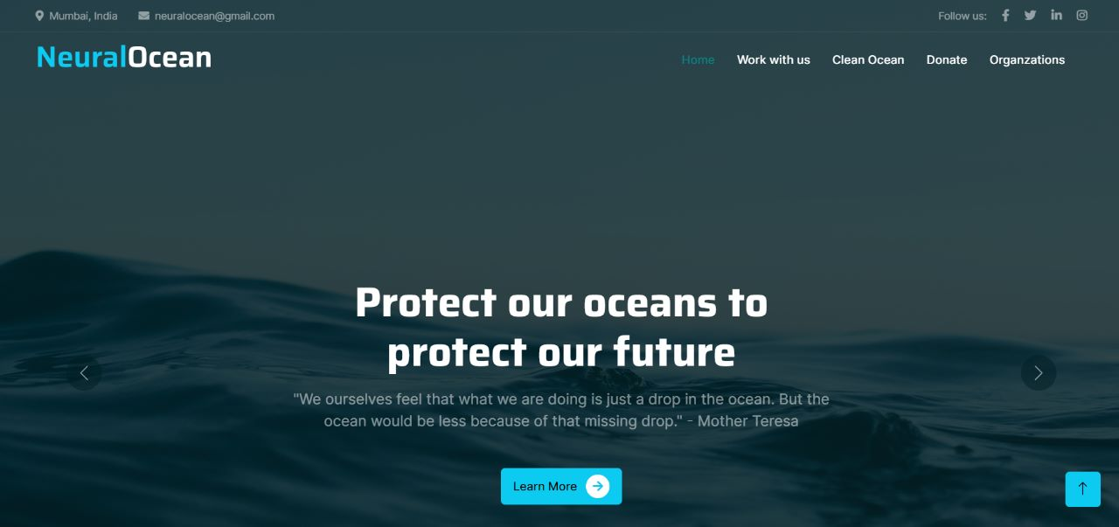**

**Fig. 5.1.1 Home Page**

**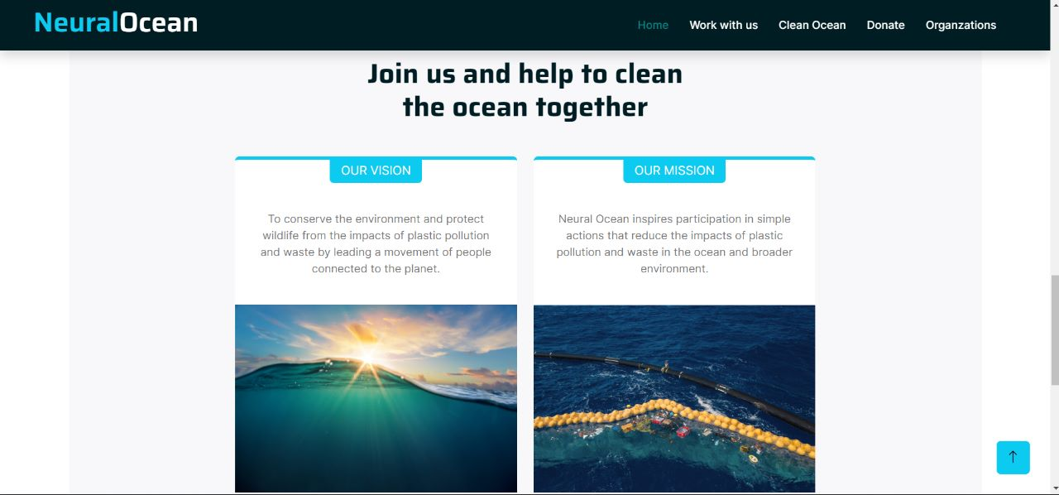**

**Fig. 5.1.2 Home Page**

**Organizations page:**

The Organizations page includes the information about the Government and NGOs that are working on the reduction of ocean pollution. The contact details of these organizations are provided along with the information. People interested in joining these groups can contact them individually.

**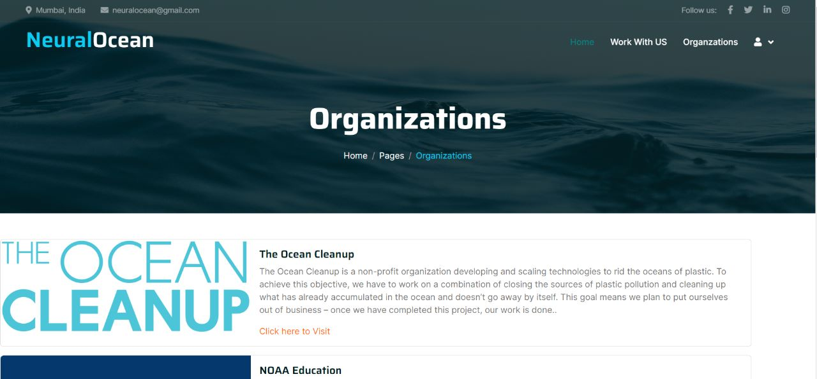**

**Fig. 5.1.3 Organizations Page**

**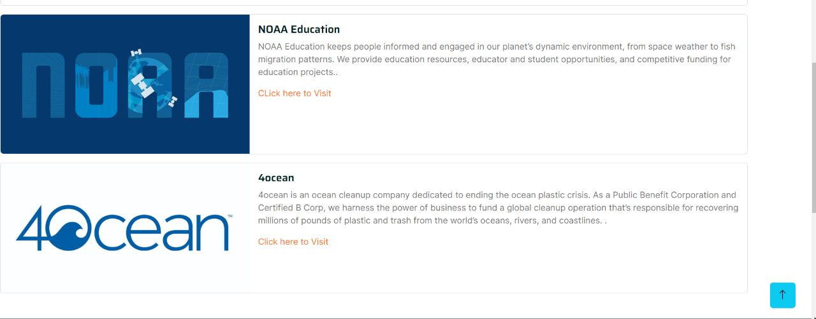**

**Fig. 5.1.4 Organizations Page**

**Donation Page:**

The Donation option is for the people who are not able to help physically so they can help financially. The Donation option helps the NGOs to grow more and motivate them to do their work more efficiently. Anyone from any part of the country can donate to these organizations through our website.

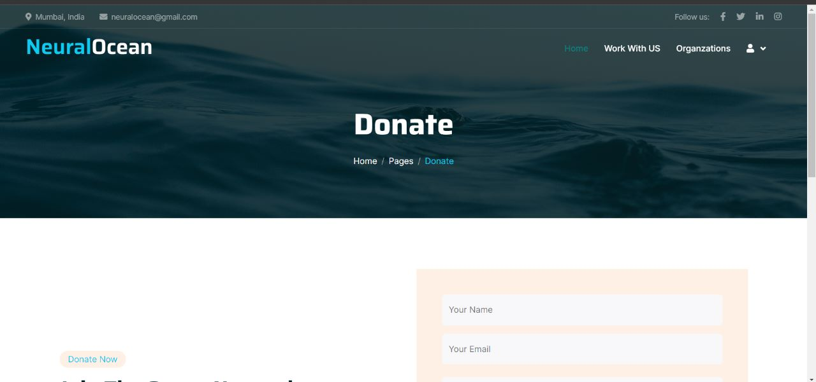

**Fig. 5.1.5 Donation Page**

**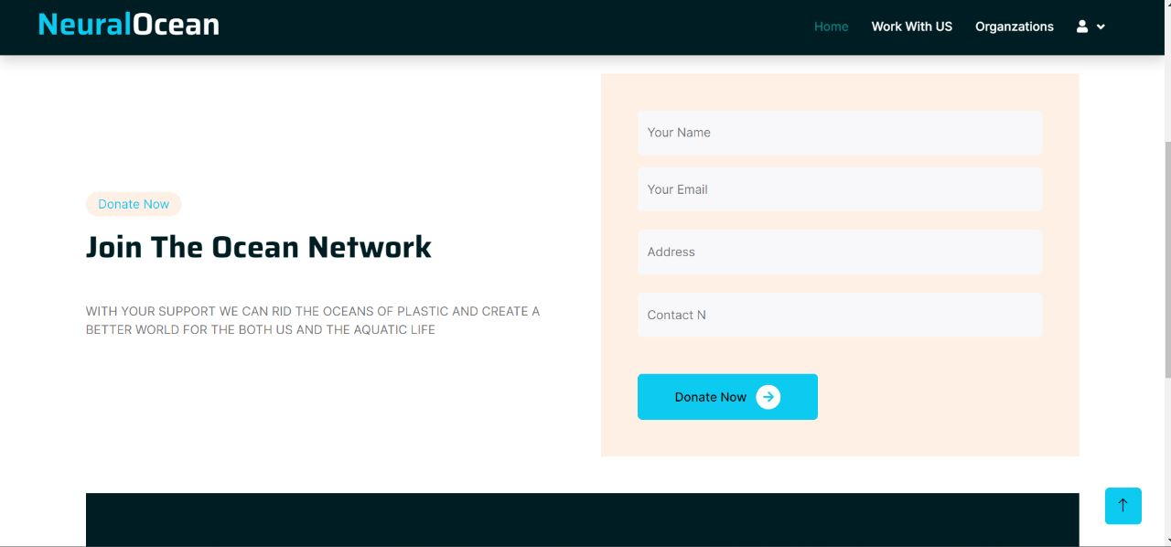**

**Fig. 5.1.6 Donation Page**

**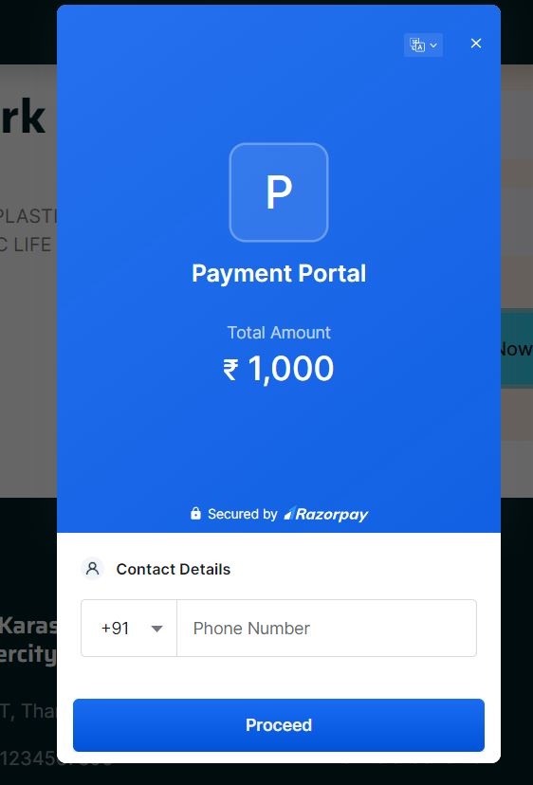**

**Fig. 5.1.7 Donation Page**

**Work with us page:**

Neural Ocean does not only provide the information about the neural waste and organizations working for it, anyone who is interested in working with our website can apply for their desired designation and join us.

**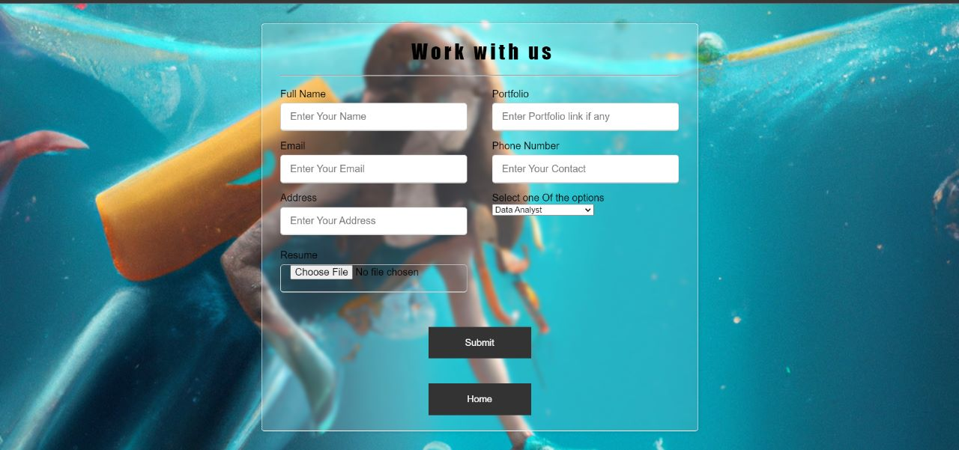**

**Fig. 5.1.8 work with us Page**

**About us Page:**

If visitors wish to learn more about our website, they can click the "about us" link on the home page. This will navigate them to a page where they can learn more about our website's developers and get full information about them, along with their social media and linkedIn handles.

**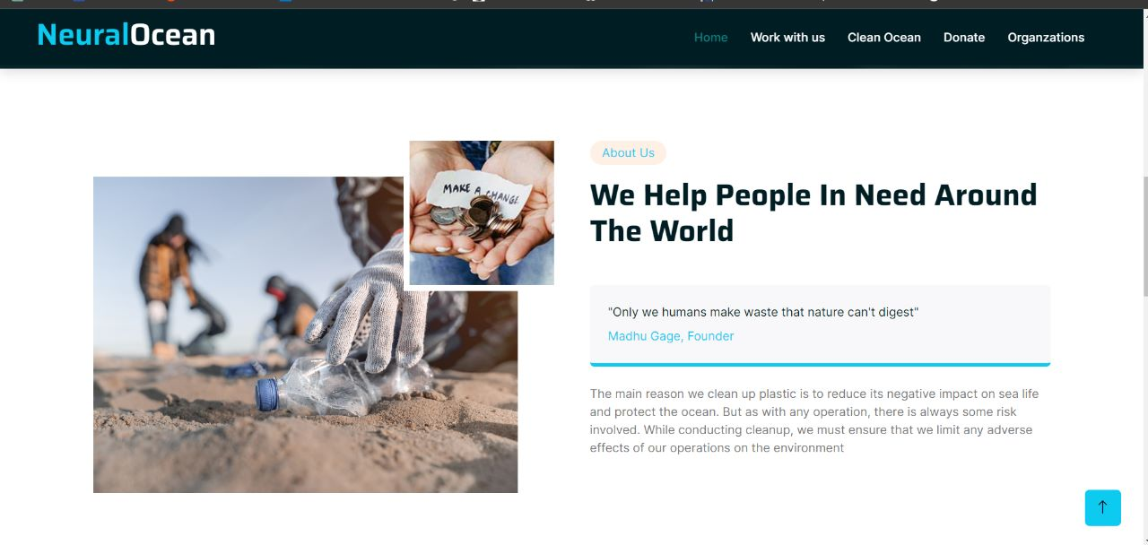**

**Fig. 5.1.10 About us Page**

### Flow chart

### C:\Users\pradn\AppData\Local\Packages\5319275A.WhatsAppDesktop_cv1g1gvanyjgm\TempState\14DA92F2BDAEC7F2218042A5B6124570\WhatsApp Image 2023-02-17 at 14.33.45.jpg

**Fig. 5.2 Flowchart**

### Use Case Diagram

### 

### Fig. 5.3.1 DFD Level 0

### Data Flow Diagram (DFD)

# C:\Users\pradn\AppData\Local\Packages\5319275A.WhatsAppDesktop_cv1g1gvanyjgm\TempState\C4819D06B0CA810D38506453CFAAE9D8\WhatsApp Image 2023-02-17 at 14.39.56.jpg

**Fig. 5.4.1 DFD Level 0**

# C:\Users\pradn\AppData\Local\Packages\5319275A.WhatsAppDesktop_cv1g1gvanyjgm\TempState\EF0EFF6088E2ED94F6CAF720239F40D5\WhatsApp Image 2023-02-17 at 14.43.36.jpg

**Fig. 5.4.2 DFD Level 1**

# Chapter 6

## Technical Specification

**Development: VS Code**

VS Code also known as Visual Studio Code is a source code editor made by Microsoft for Windows, Linux, MacOS. It has various features such as Debugging, Syntax highlighting, extension, intelligent code completion.

**Frontend: Html, CSS, JavaScript**

As a web developer, the three main languages we use to build websites are HTML, CSS, and JavaScript. JavaScript is the programming language, we use HTML to structure the site, and we use CSS to design and layout the web page. These days, CSS has become more than just a design language, though. You can implement animations and smooth transitions with just CSS.

**Additional tool: Bootstrap**

Bootstrap is a free and open-source CSS framework directed at responsive, mobile-first front-end web development. It contains HTML, CSS and (optionally) JavaScript-based design templates for typography, forms, buttons, navigation, and other interface components.

**OS: Windows**

Windows is a graphical operating system developed by Microsoft. It allows users to view and store files, run the software, play games, watch videos, and provides a way to connect to the internet. It was released for both home computing and professional works.

**Backend: PHP, MySQL**

With PHP, you can connect to and manipulate databases. MySQL is the most popular database system used with PHP. PHP combined with MySQL are cross-platform (you can develop in Windows and serve on a Unix platform). The data in a MySQL database are stored in tables. A table is a collection of related data, and it consists of columns and rows. Databases are useful for storing information categorically.

**Machine Learning Based Algorithm: Convolution Neural Network**

A **Convolutional Neural Network (CNN)** is a type of Deep Learning neural network architecture commonly used in Computer Vision. Computer vision is a field of Artificial Intelligence that enables a computer to understand and interpret the image or visual data.  Neural Networks are used in various datasets like images, audio, and text. Different types of Neural Networks are used for different purposes, for example for predicting the sequence of words we use [**Recurrent Neural Networks**](https://www.geeksforgeeks.org/introduction-to-recurrent-neural-network/) more precisely an [LSTM](https://www.geeksforgeeks.org/understanding-of-lstm-networks/), similarly for image classification we use Convolution Neural networks.

In a regular Neural Network, there are three types of layers:

1. **Input Layers:** It is the layer in which we give input to our model. The number of neurons in this layer is equal to the total number of features in our data (number of pixels in the case of an image).
2. **Hidden Layer:** The input from the Input layer is then feed into the hidden layer. There can be many hidden layers depending upon our model and data size. Each hidden layer can have different numbers of neurons which are generally greater than the number of features. The output from each layer is computed by matrix multiplication of output of the previous layer with learnable weights of that layer and then by the addition of learnable biases followed by activation function which makes the network nonlinear.
3. **Output Layer:** The output from the hidden layer is then fed into a logistic function like sigmoid or SoftMax which converts the output of each class into the probability score of each class.

## Chapter 7

## Project Scheduling

|  |  |  |  |
| --- | --- | --- | --- |
| **Sr. No** | **Group Member** | **Time duration** | **Work to be done** |
| **1** | Madhu Gage,  Darpan Mhatre,  Rohan Ahire | 2nd week of January | Finalize the topic and designing the frontend GUI. |
| **2** | 1st week of February | Working on front end GUI with home page |
| **3** | Mid of Februrary | Creating Organizations page and work with us page. |
| **4** | Last week of February | Connecting organizations page and work with us page to home page |
| **5** | 1st week of March | Creating Donation page and check it’s working. Connecting Donation Page to Home page. |
| **6** | Mid of March | Working on Implementation of ML Algorithm. Training the AI model. |
| **7** | Last week of March | Connecting the Algorithm with the project and check the final implementation |

# Chapter 8

## Result and Discussion

## The use of plastic is increasing day-by-day, this leads to a lot of generation of plastic waste. This waste includes plastic carry bags, bottles, wrappers of snacks and other items, etc. The plastic waste that is generated is directly thrown into the water bodies. As we all know, plastic takes millions of years to decompose and keeps floating on the surface of water for years and then settles down at the bottom of the ocean. Not only plastic but other wastes like garbage, fishing nets, etc. is also dumped in the ocean directly. This waste pollutes the ocean, and harms the aquatic life. Many species are endangered because of the ocean pollution. Neural Ocean has taken an initiative to stop ocean pollution, protect water resources, and preserve aquatic life. By using the deep learning algorithm we can detect the waste present on the surface of the water body and help the organization to clean the water bodies by providing them the location and data about it. Convolution Neural Network (CNN) Algorithm helps to detect the object and detects it with great percentage of accuracy. CNN uses three layers for identification of the image. First layer, being the INPUT LAYER accepts the uploaded image and determines the number of neurons in the image. Here the number of neurons equals to the number of features in the image. Second layer is the HIDDEN LAYER. The input from the input layer is then fed towards the hidden layer. A system can consist of number of hidden layers depending upon the size of the datasets and size of the images that are being uploaded. Each hidden layer can have different numbers of neurons which are generally greater than the number of features. The output from each layer is computed by matrix multiplication of output of the previous layer with learnable weights of that layer and then by the addition of learnable biases followed by activation function which makes the network nonlinear. The last layer is the OUTPUT LAYER. The output from the hidden layer is then fed into a logistic function like sigmoid or SoftMax which converts the output of each class into the probability score of each class.

# Chapter 9

## Conclusion and Future Scope

## Conclusion:

## The specific work we did in this project, implementing a CNN for identification of waste and aquatic life, show promise with regards to computational performance. Concerning the accuracy, the network did not perform as well as we would have hoped. However, we believe that with some improvements of the training data set 23 and network parameters we could improve the accuracy sufficiently.

## Future Scope:

## The future development we would recommend includes:

## Improving the training data by several means: Simulate for better balance, using pre-processing, get more data for the number of track identification.

## Tuning and customizing the parameters of the network, regarding structure, layers, filters etc.

## Improving model to not only detect but also classify the waste and aquatic life detected.

## References

1. Water Quality Mapping with GPS and GIS in Indian States (2016), Geospatial World.
2. Image Semantic Segmentation of Underwater Garbage (2022), Dr. Boguslaw Cyganek.
3. The Ocean Cleanup (2014), Lithom Roswell
4. Plastic management System (2019), Ministry of Housing & Urban Affairs Government of India
5. Ocean Waste in the Gulf of Honduras (2013), Mr. M. Lu